CLUB MANAGEMENT SYSTEM
[Type the document subtitle]

Table of Contents
Background 3
Project scope 3
Existing System 3
DISADVANTAGES: 3
Proposed System 4
tain time also it is used to create the operation just like insert, update, and display, delete the records. 4
OBJECTIVE: 4
Database design: 5
User manual: 6
Homepage 6
President 7
Add 7
Location 8
Add 8
Student 12
Edit 15
Delete 17
Membership 20
Club 25
President 26
Testing 32

Background

Project scope
We have necessary to establish an MVC application in this project. MVC is nothing but the controller functionalities by the customer requirement. The users can store all the information just like the model, and view. MVC is used to solve all the issues in the asp.net that’s the way the MVC is a very important framework. The advanced version of asp.net is MVC. In that the project, we have the effort on the application. In this assignment, we need to inscribe the code of the application intended for the registration information, attendance information by the use of MVC application. The MVC application is used to store every information and it is used to decrease the gap in the application or distance the management.

Existing System

In the club, there are not involves application usage in it. Then the club fetches most of the problems that are related to managing all the information of the sport. It helps to maintain every information in excel and paper. And it helps for the time consuming also make the problems of maintaining all the information.

DISADVANTAGES:

- Difficult and increase the time to complete the work
- Use extra paperwork
- Not Computerization control

Proposed System

Purpose of this application system is to improve the reliable and flexible system. In this assignment, I have improved the computer system with the use of C#.net. This is a programming language by using the MVC asp.net. This programming application creates a system that is more reliable and flexible. Also creates every difficult work that is easy to maintain and manage all the record. In this report, we have saved every information in the SQL server. This application system is used to maintain time also it is used to create the operation just like insert, update, and display, delete the records.

OBJECTIVE:
There are most of the objectives and this is as following:
1. The system is used to insert, update, and display the record.
2. In this assignment, we have to make the design to attract the customer also make the UI that the system is user-friendly.
3. The highest purpose of this system application is to access every information in the database with the functionality by the user.
4. The system has the security of the application also it's not agreed to log on the user.

Database design:

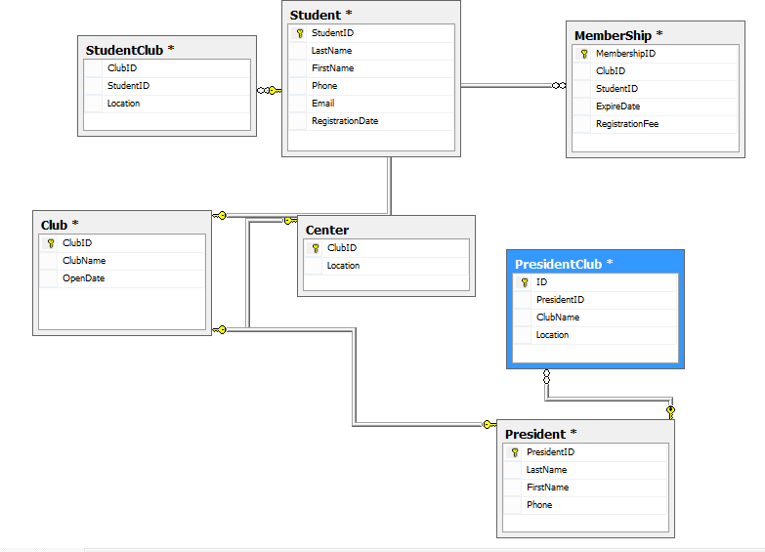

We have used the MVC architecture in the entire report. In the system, the architecture has to contain the maximum flexible architecture. MVC architecture, you can isolate the design, controller, model that the work easily and smoothly that is running in the application. The MVC is using to increase the execution speed and avoid the Wight of the code. Because in the asp.net MVC there are not allows the View State. It is used to fast development and decrease the writing cost and reading cost.

Register
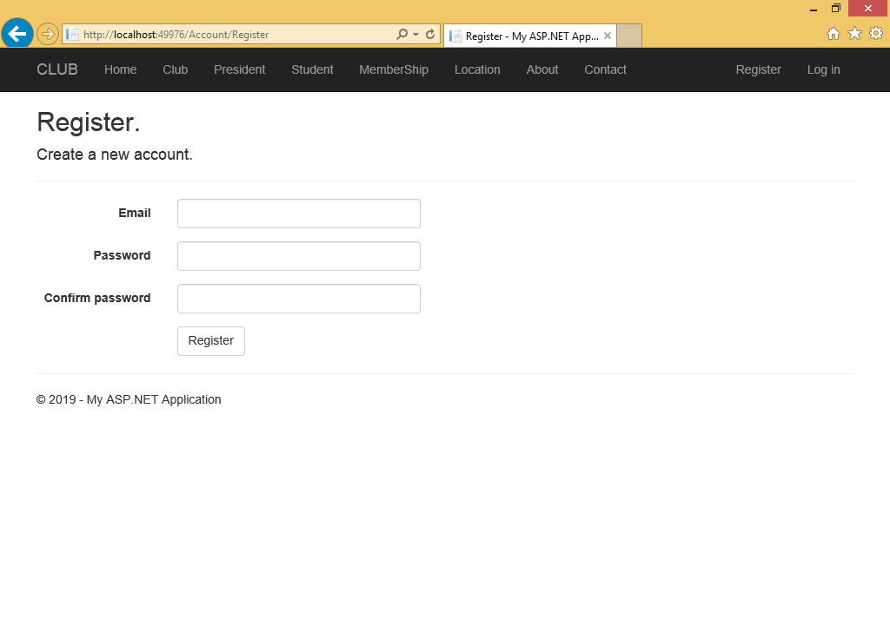

Login
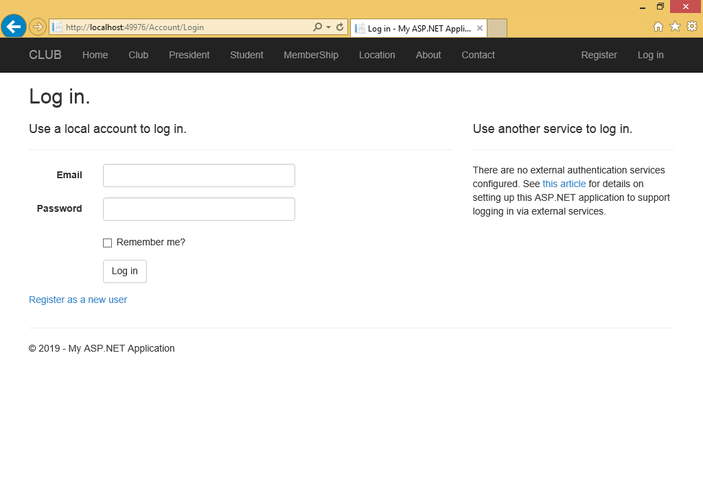

User manual:

Homepage
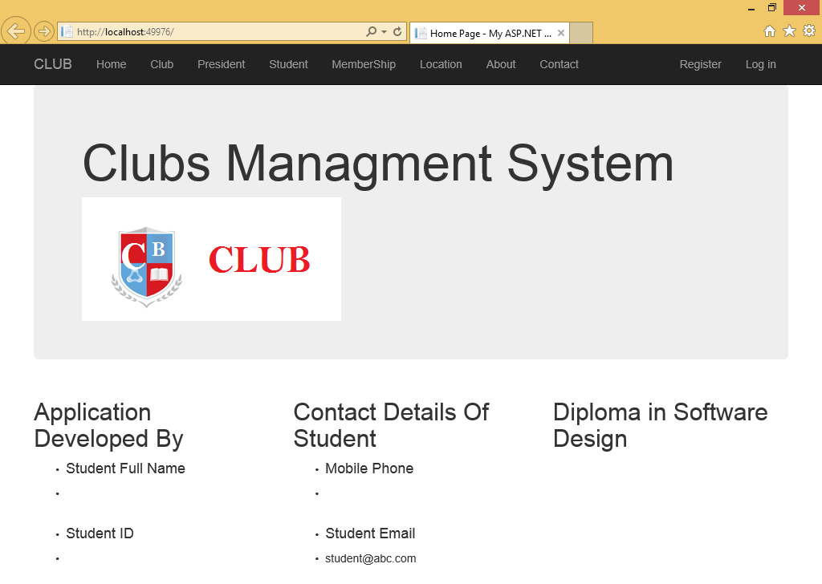

President

Add
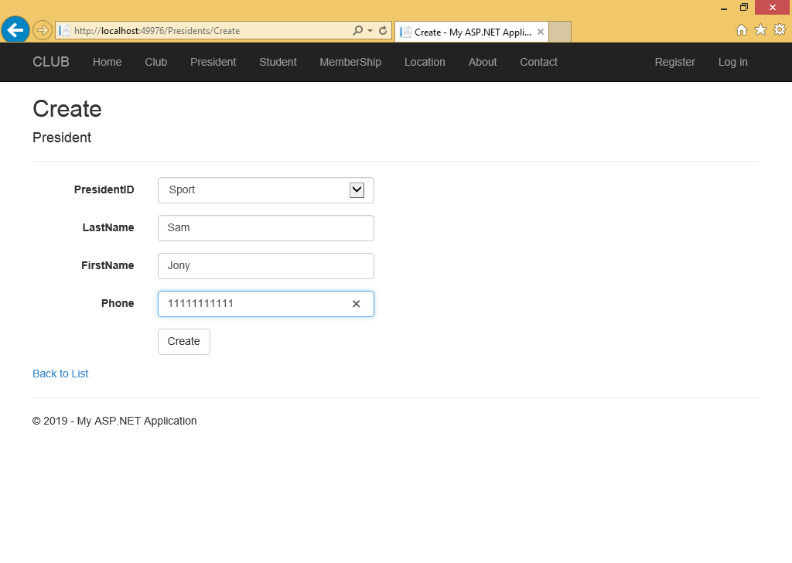

Location

Add
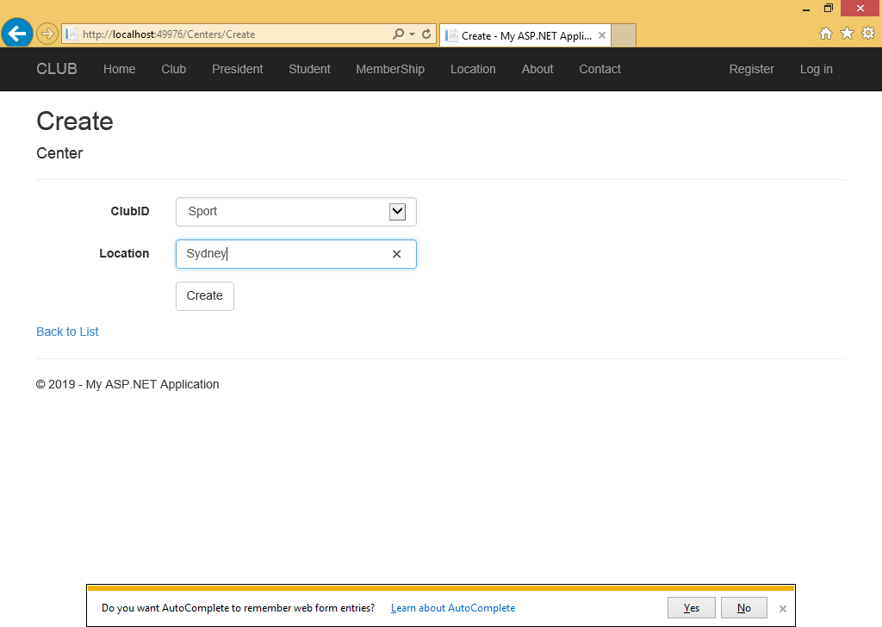

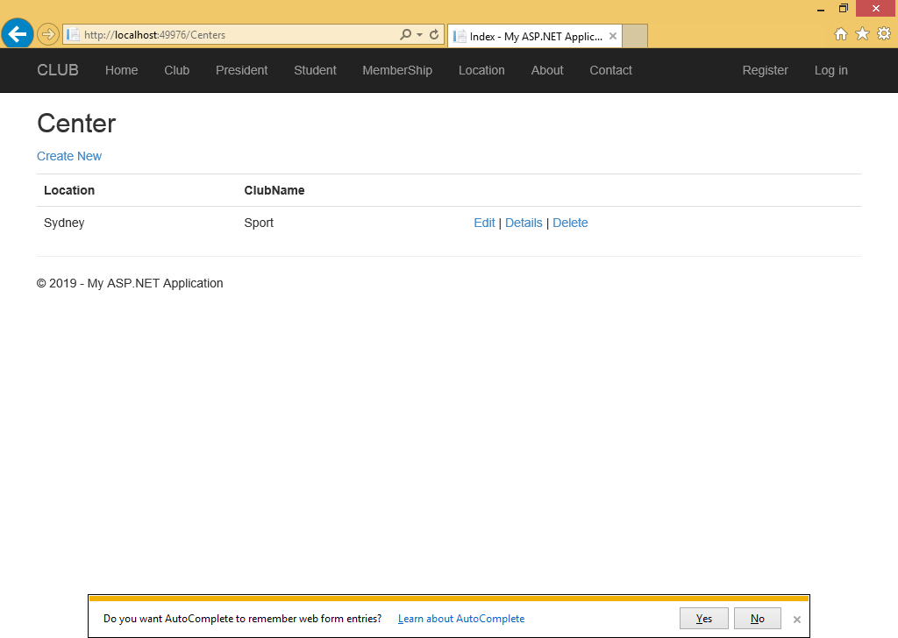

Edit
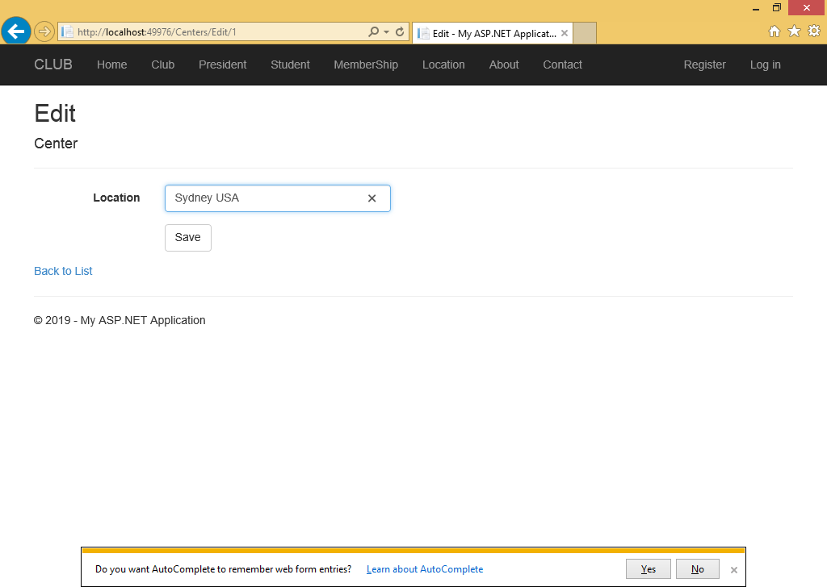

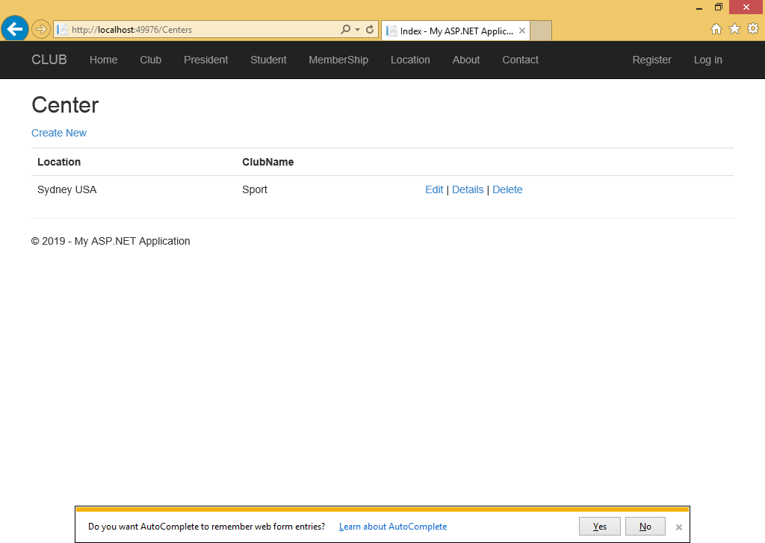

View
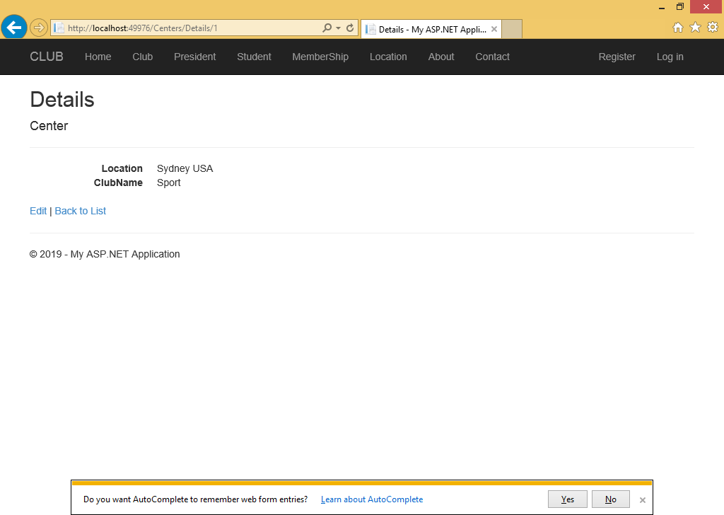

Student

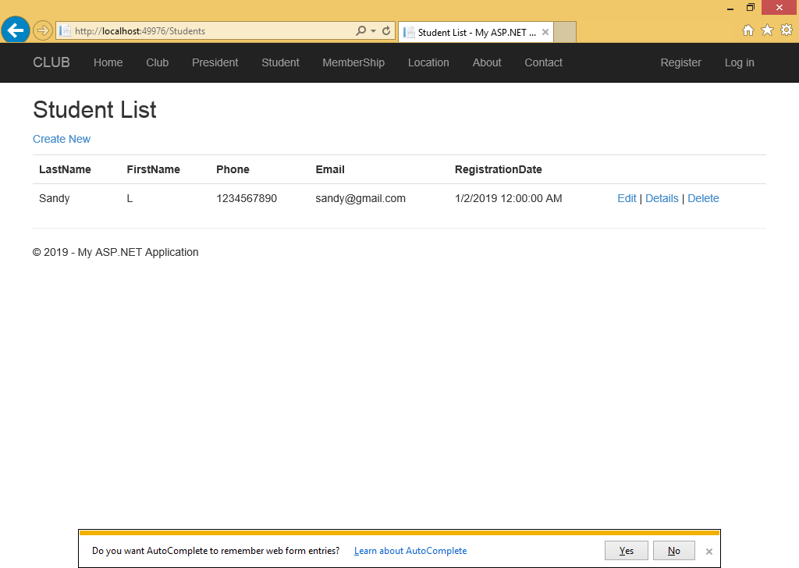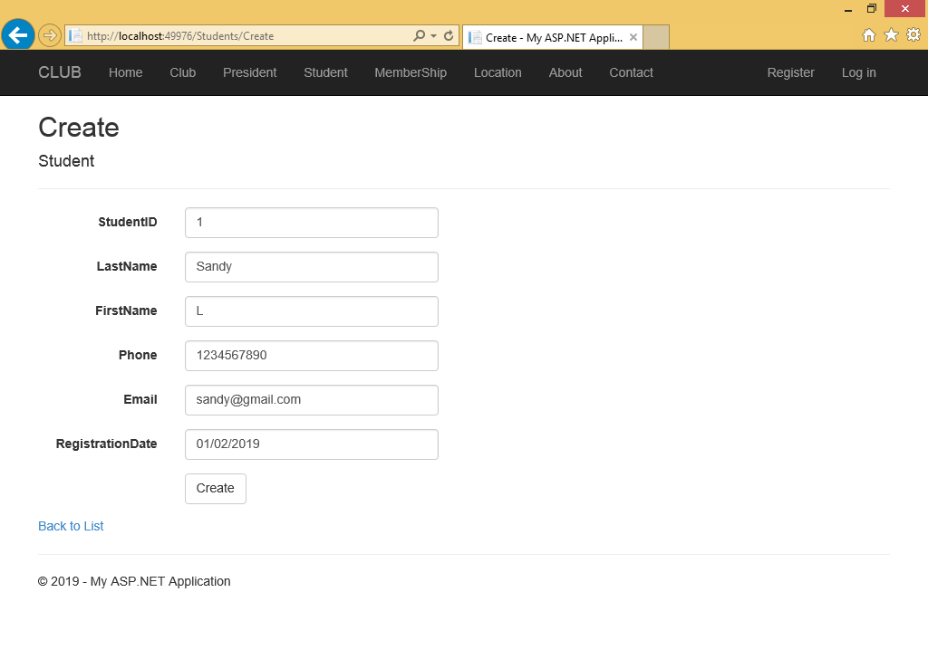

Edit
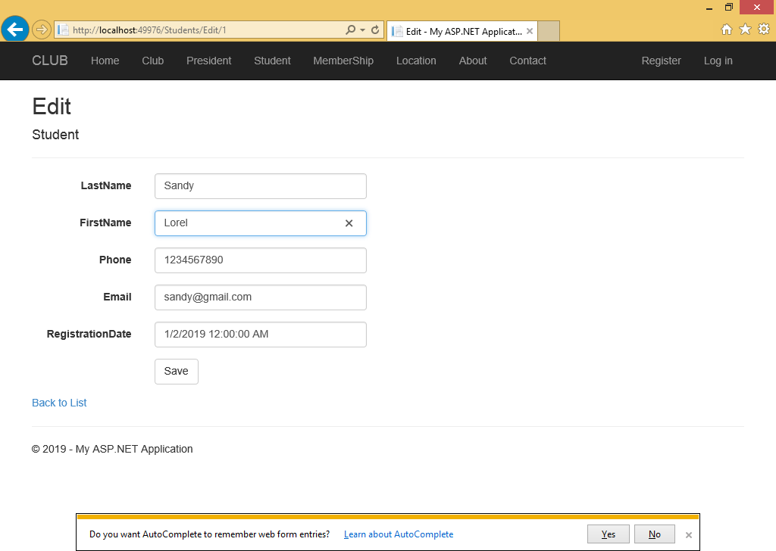

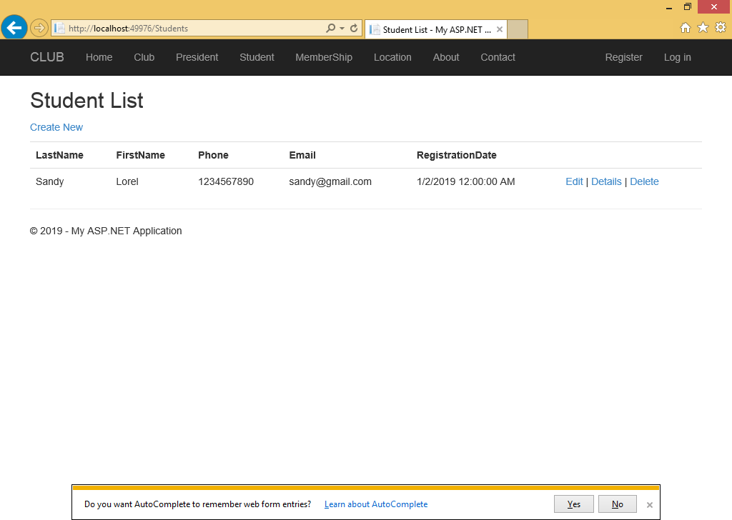

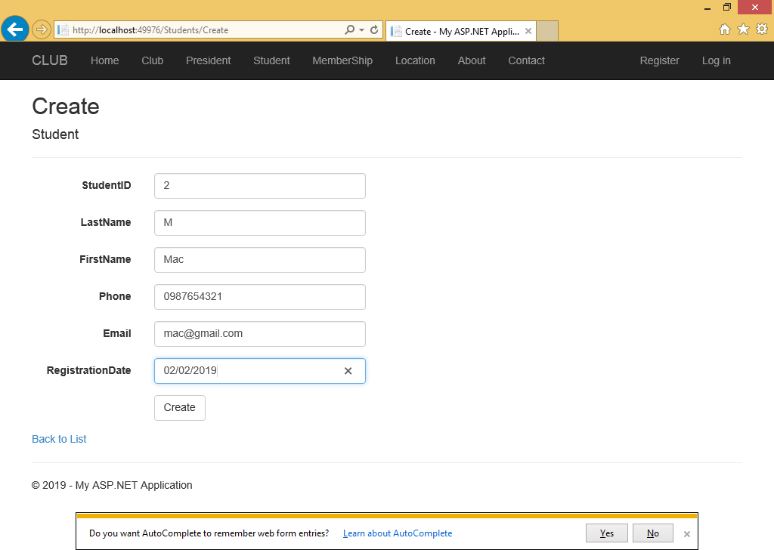

Delete

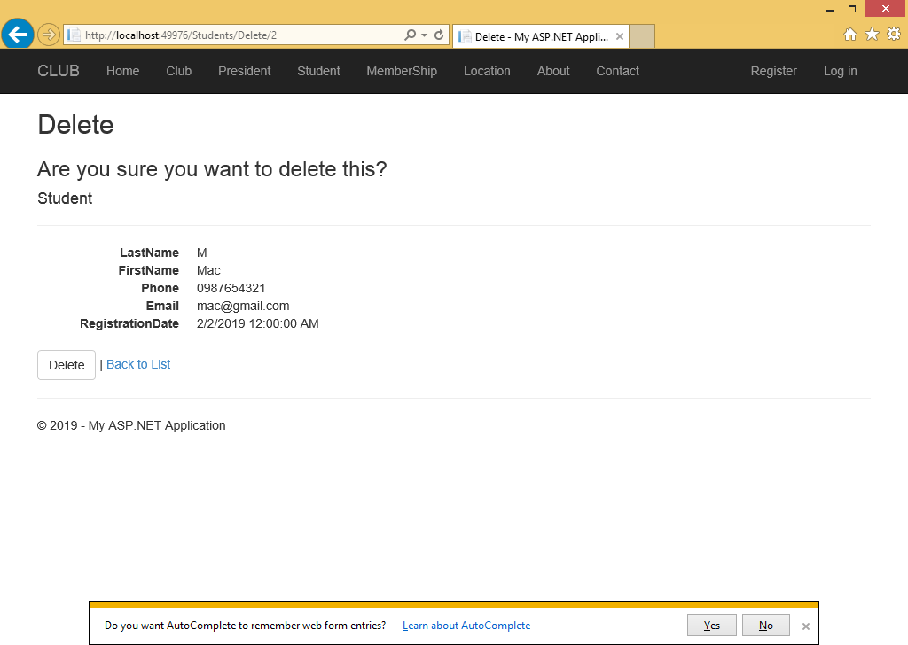

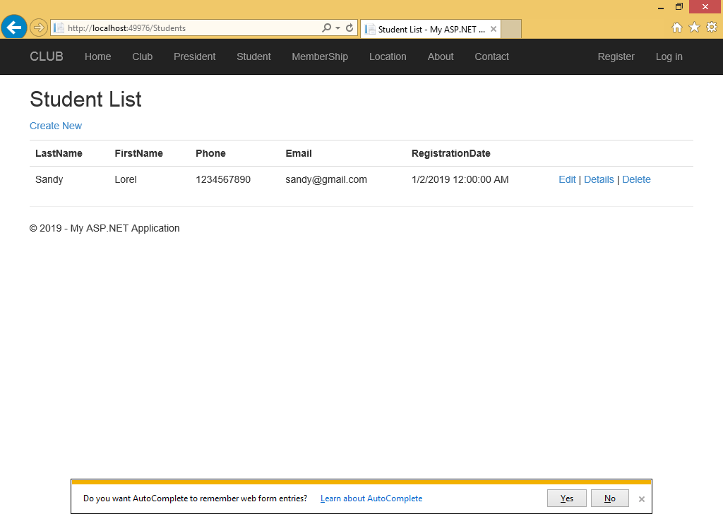

Membership

Add
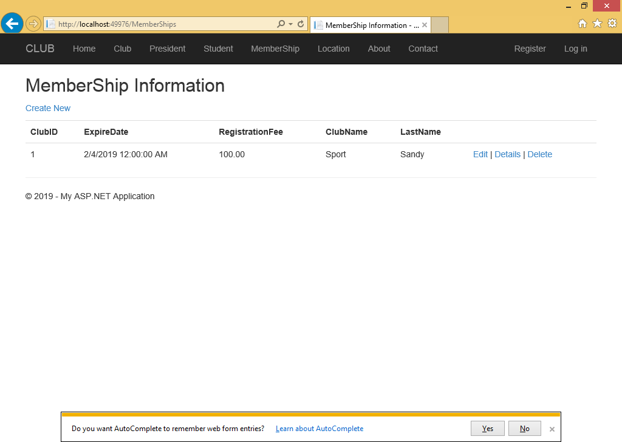

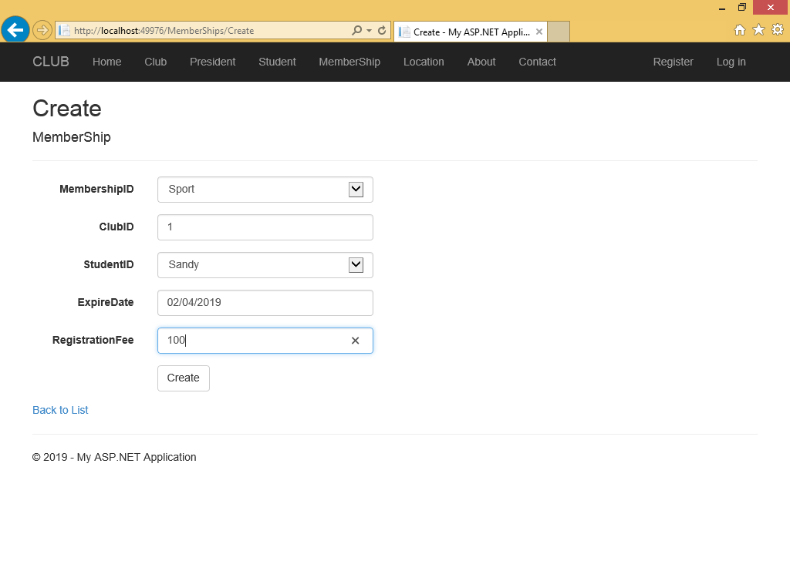
Edit
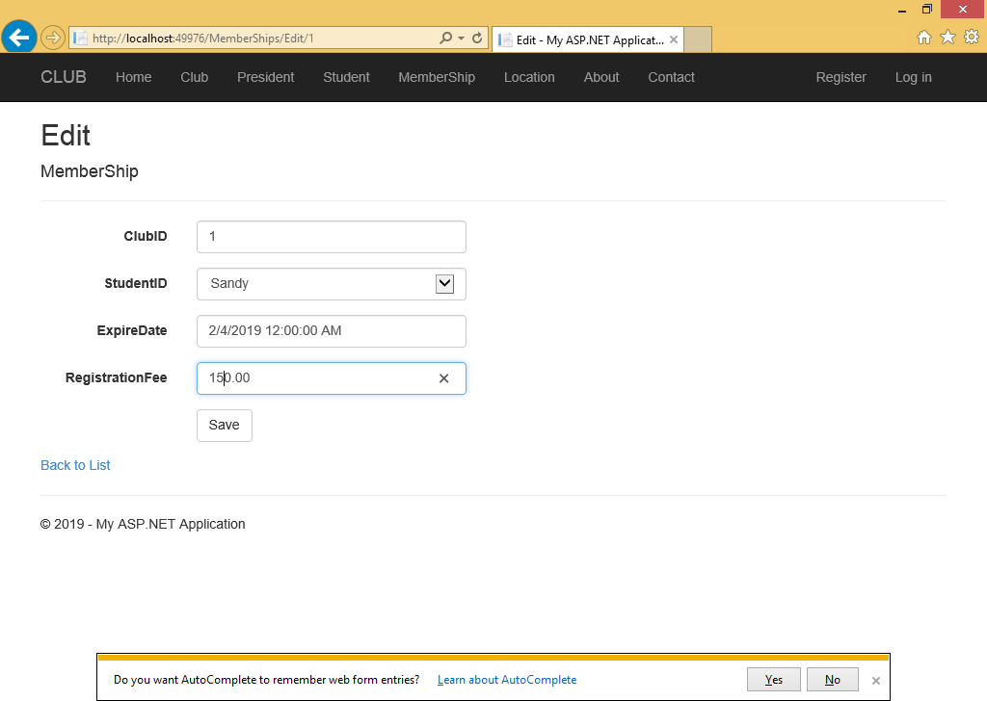

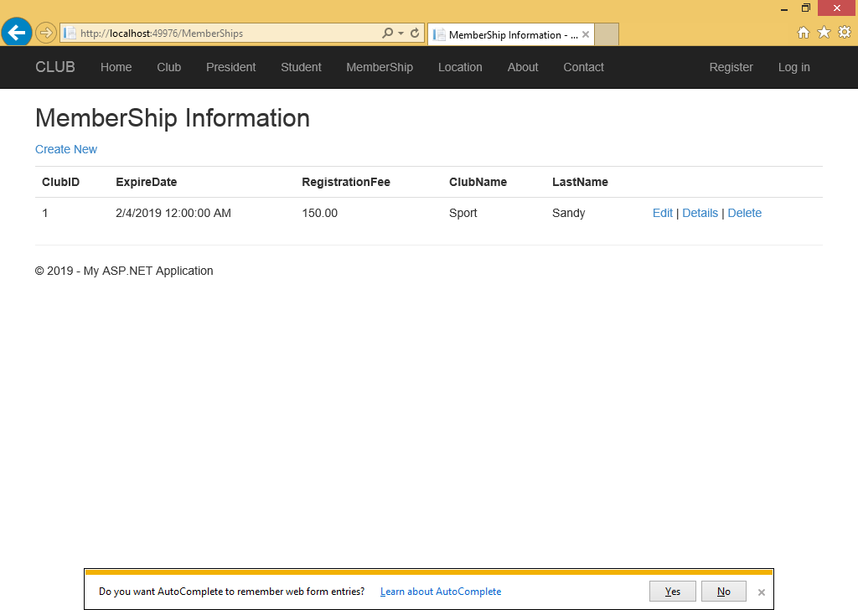

View
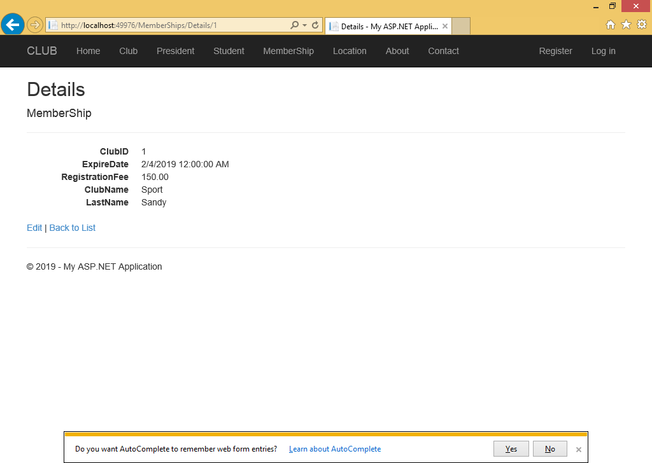

Club
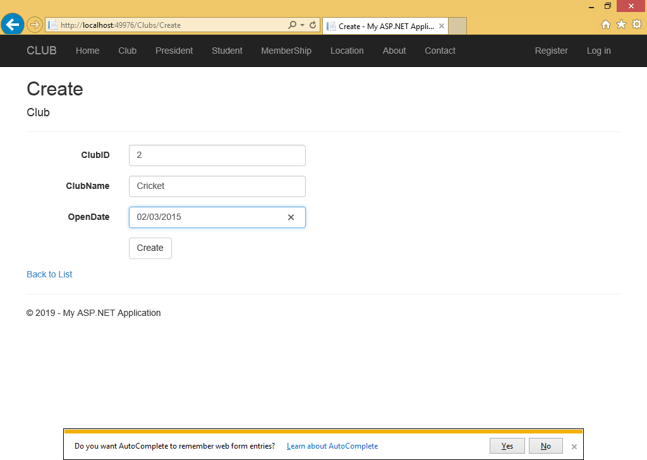

President
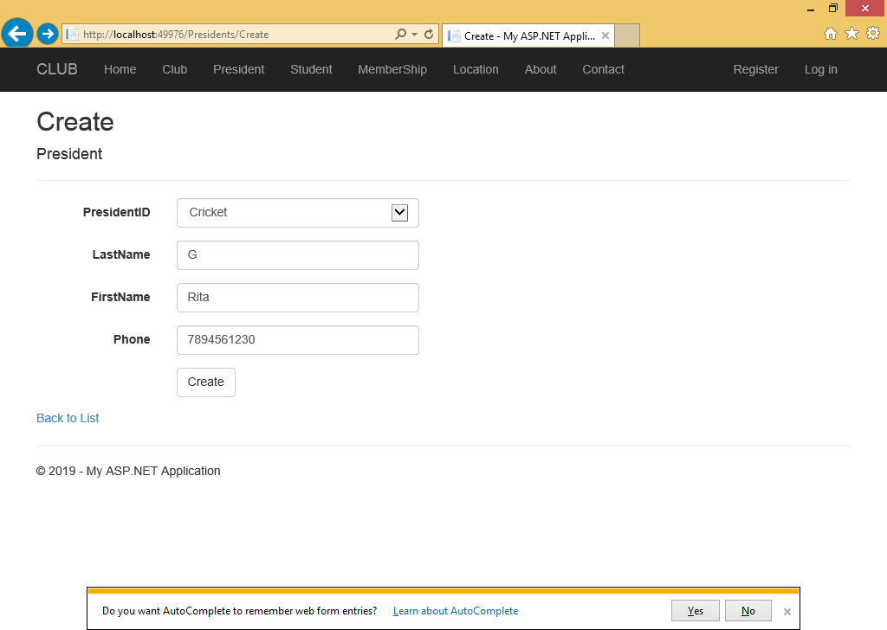

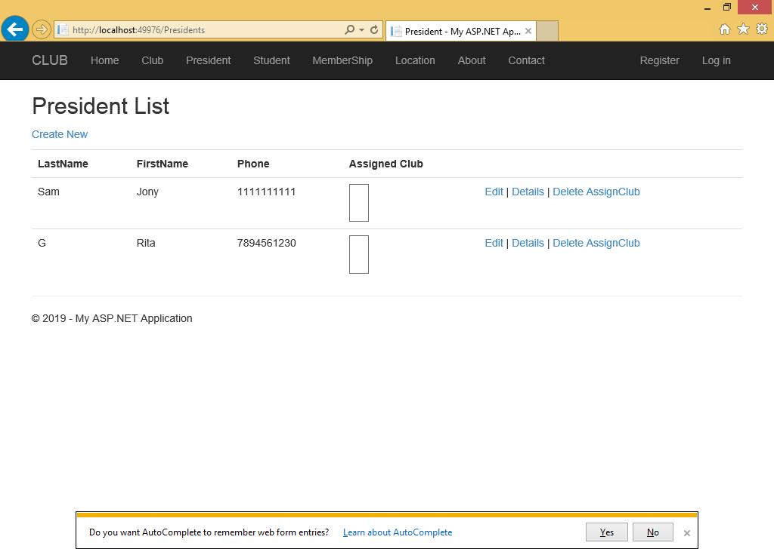

Assign Club

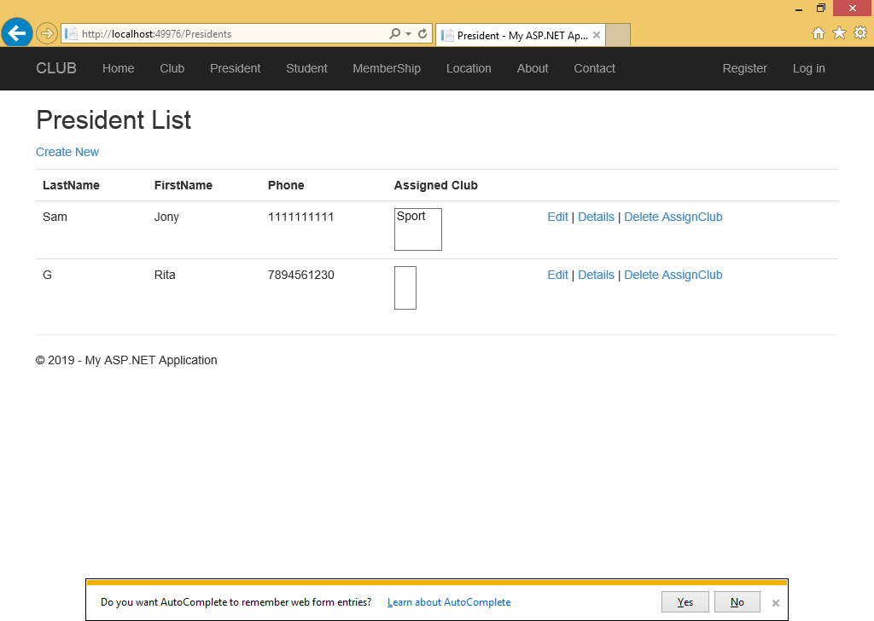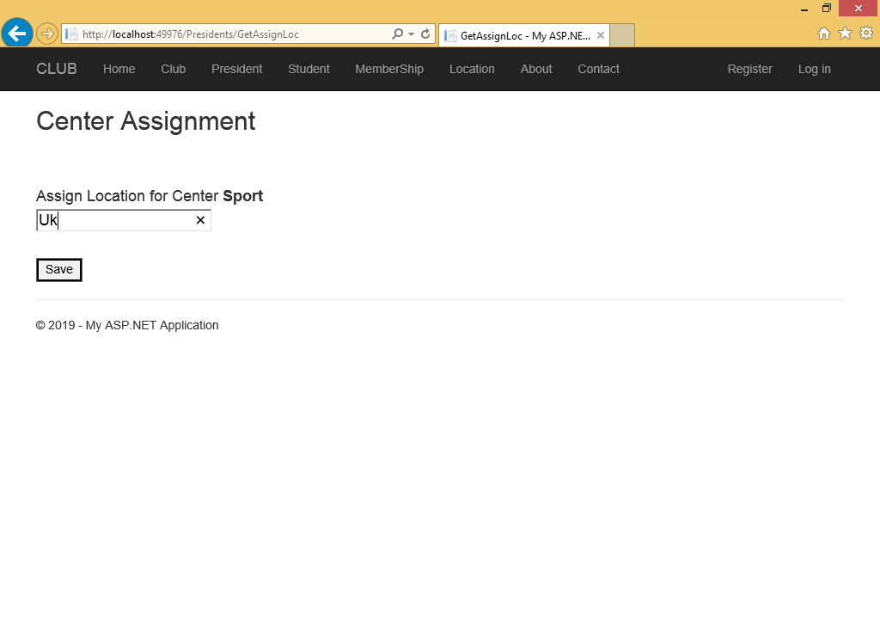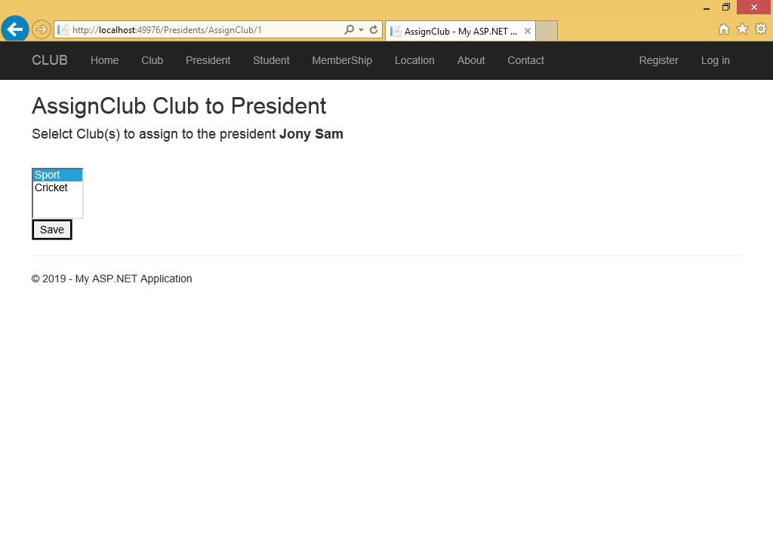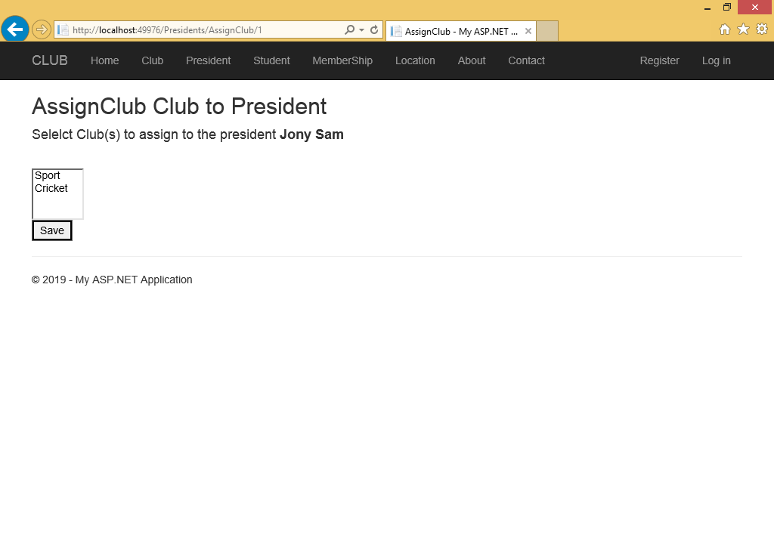

Testing

SrNo | Test | Screen | Status
1 Club | Add  If not valid show validation error | 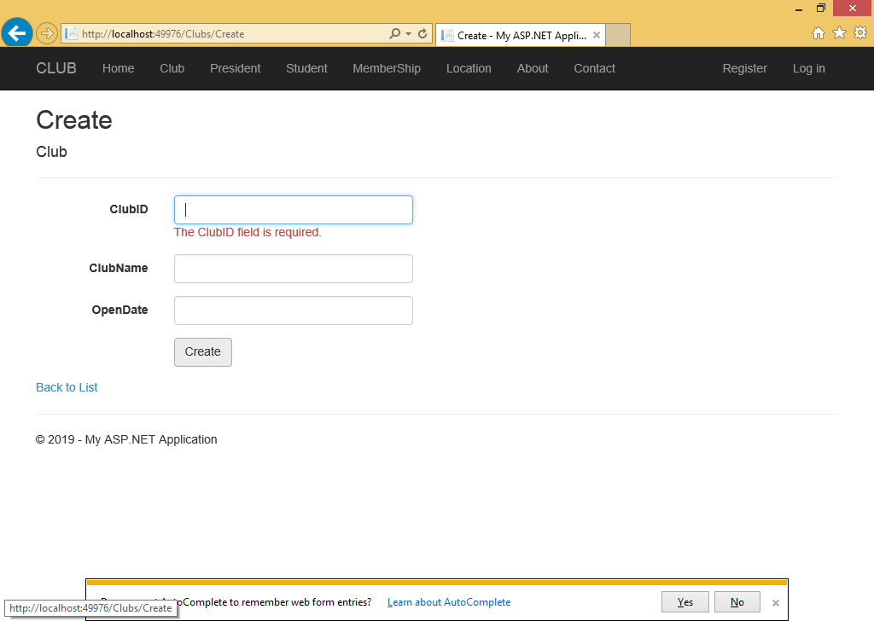 | Pass
 | Update  After an update, it should be updated successfully | 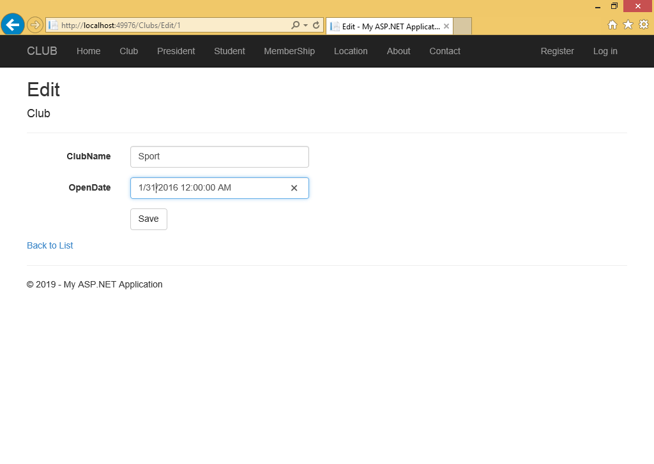  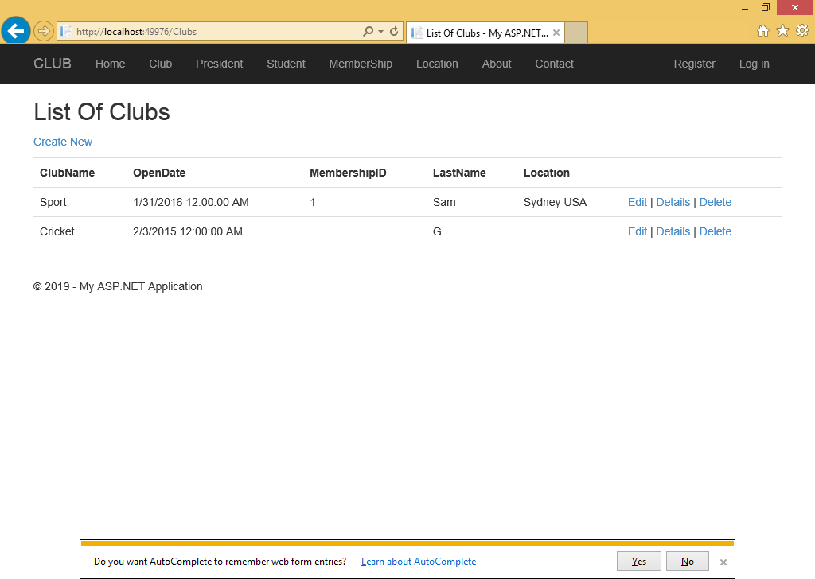 | Pass
 | View  I click on view details should be view in new page | 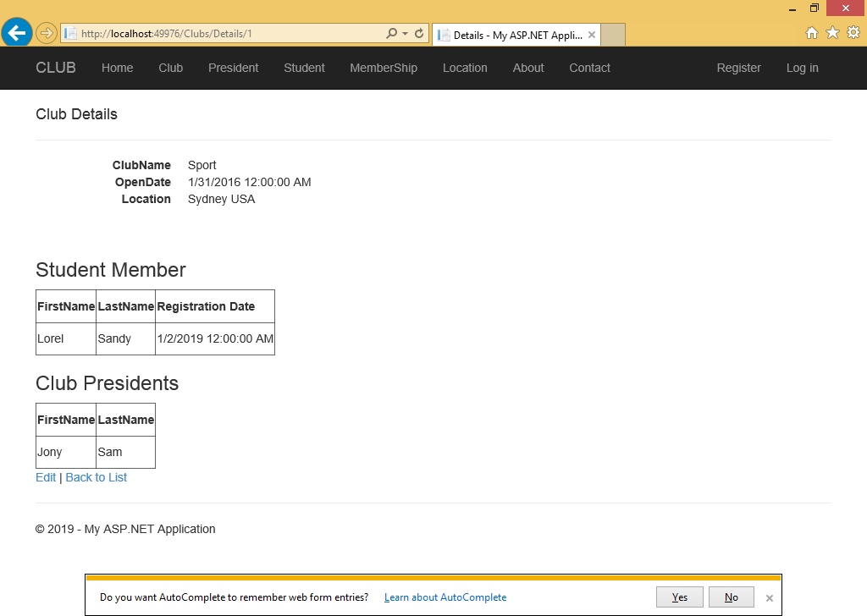 | Pass
 | Delete id click in delete record should be deleted | 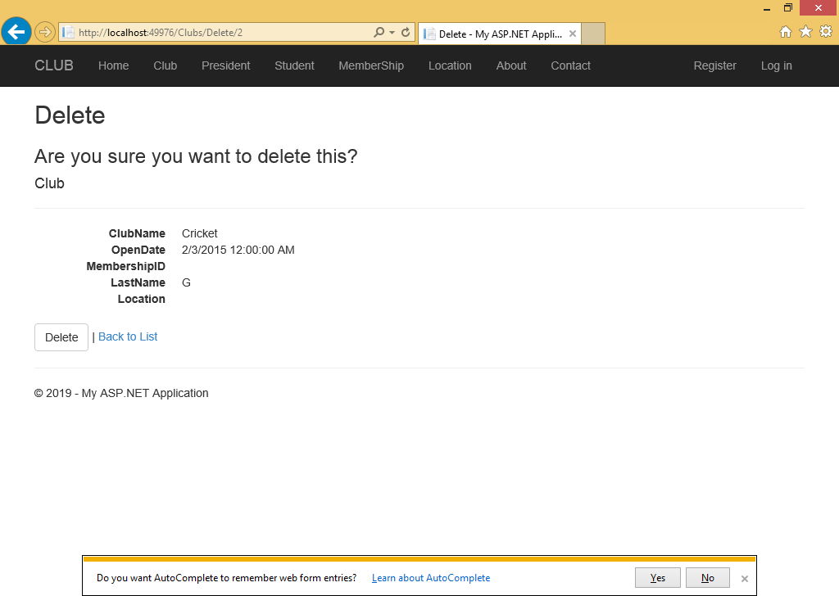
2 Center | Add  If record add it should save successfully | 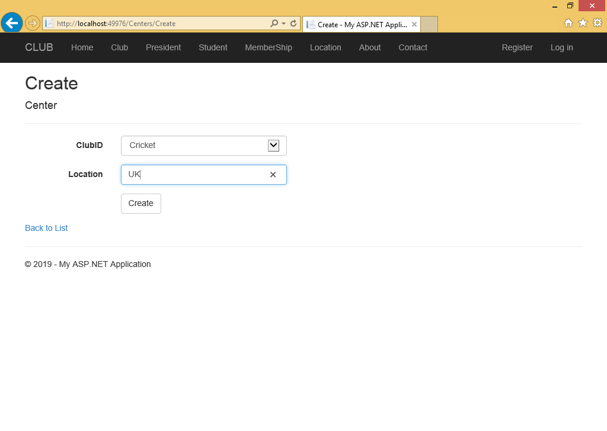  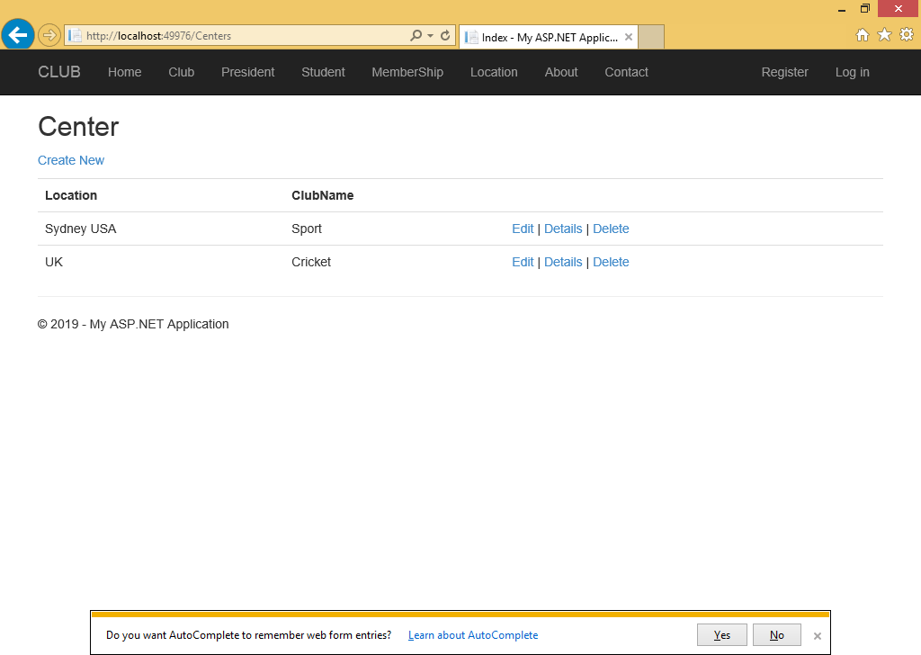 | Pass
 | Update | 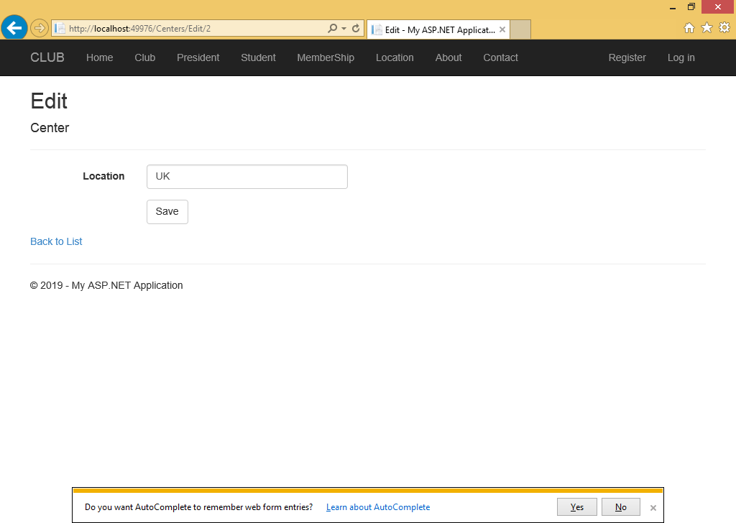  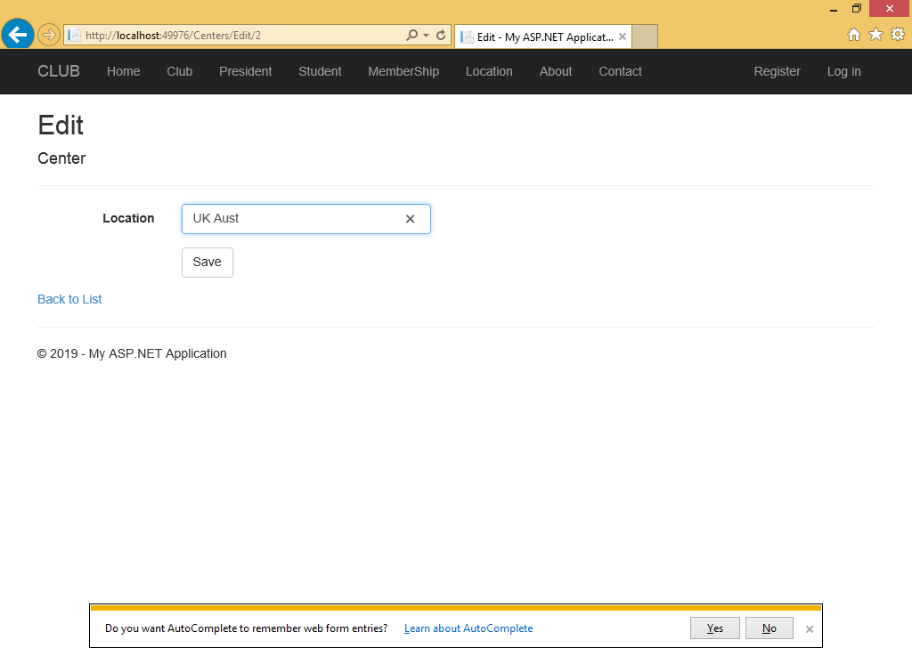  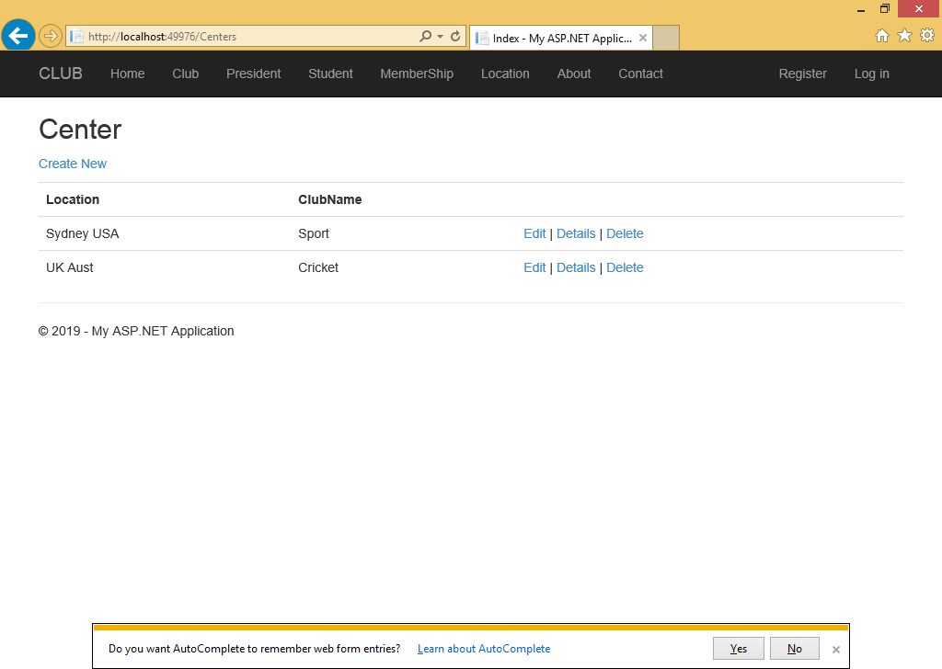 | Pass
 | View  When click on details record will be shown on a new page | 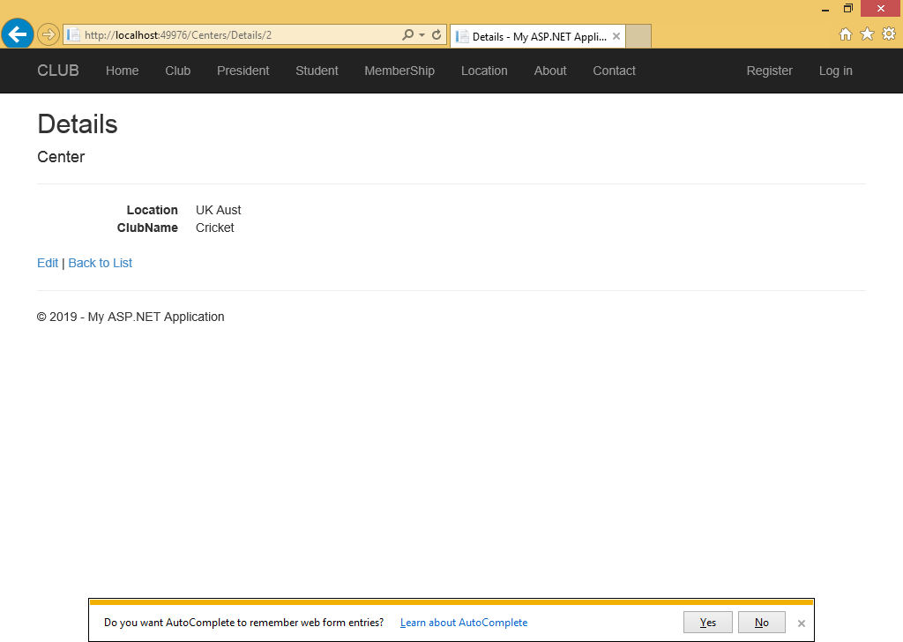 | Pass
 | Delete  I click on delete button record should be deleted | 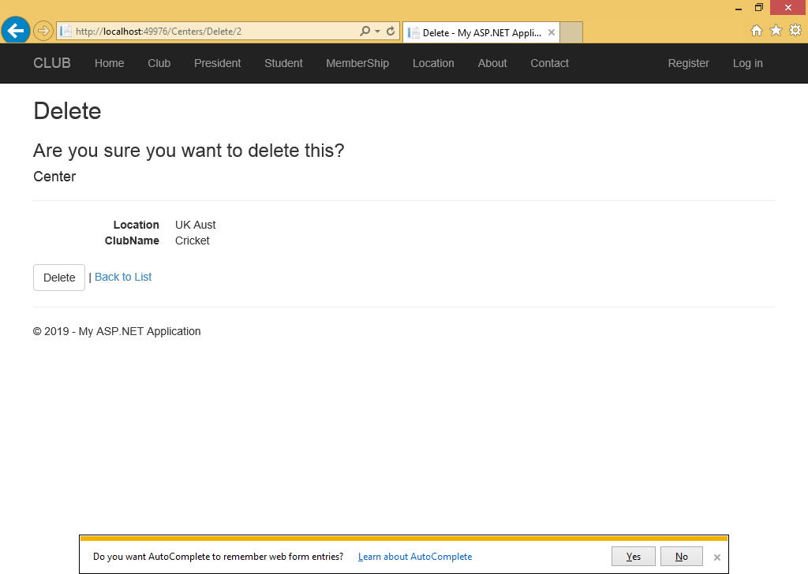  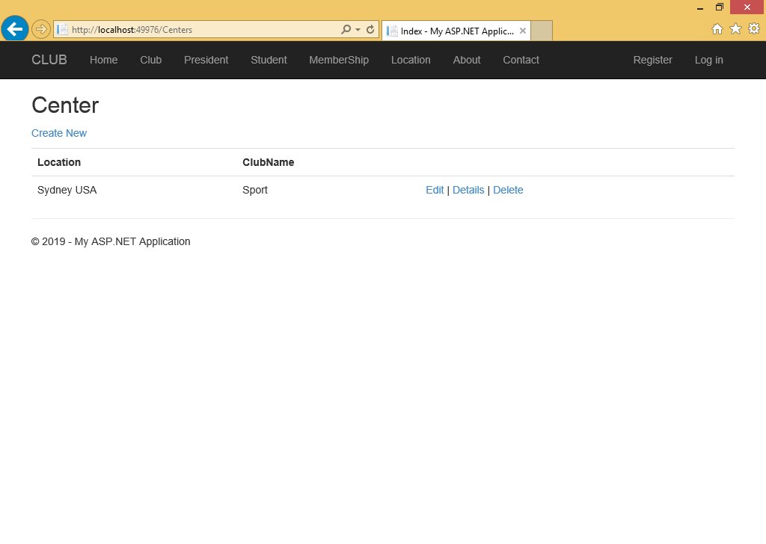 | Pass

